**CHANDIGARH UNIVERSITY**

**UNIVERSITY INSTITUTE OF ENGINEERING**

**DEPARTMENT OF COMPUTER SCIENCE & ENGINEERING**



|  |  |
| --- | --- |
| **Submitted By:** Sahil Kaundal  **Submitted To:** Neeru Sharma | |
| **Subject Name** | Programming Based Learning Java (Lab) |
| **Subject Code** | 20CSP-321 |
| **Branch** | Computer Science Engineering |
| **Semester** | 5th |

LAB INDEX

**NAME:** Sahil Kaundal **SUBJECT NAME:** PBLJ (Lab)

**UID:** 21BCS8197 **SUBJECT CODE:** 20CSP-321

**SECTION:** 20BCS_WM-616/A

|  |  |  |  |  |  |  |  |
| --- | --- | --- | --- | --- | --- | --- | --- |
| **Sr.No** | **Program** | **Date** | **Evaluation** | | | | **Sign** |
| **LW**  **(12)** | **VV**  **(10)** | **FW**  **(8)** | **Total**  **(30)** |
| 1. | Create an application to save the employee information using arrays. | 16/08/2022 |  |  |  |  |  |
| 2. | Design and implement a simple inventory control system for a small video rental store. | 20/08/2022 |  |  |  |  |  |
| 3. | Create a application to calculate interest for FDs, RDs based on certain conditions using inheritance. | 27/08/2022 |  |  |  |  |  |
| 4. | Create a program to set view of Keys from Java Hashtable. | 27/09/2022 |  |  |  |  |  |
| 5. | Create a program to show the usage of Sets of Collection interface. | 27/09/2022 |  |  |  |  |  |
|  |  |  |  |  |  |  |  |

**Experiment 5**

**Student Name:** Sahil Kaundal **UID:** 21BCS8197

**Branch:** BE CSE (Lateral Entry) **Section/Group:** 616/A

**Semester:** 5th **Date of Performance:** 27/09/2022

**Subject Name:** PBLJ Lab **Subject Code:** 20CSP-321

1. **Aim/Overview of the practical:**

Create a program to show the usage of Sets of Collection interface.

1. **Task to be done/ Which logistics used:**

Write the program to create an application to perform operation a set manipulation.

1. **Apparatus / Simulator Used:**

* Eclipse IDE - (Java)
* NetBeans.
* JDK-8 or any.

1. **Programs/ Code:**

**File: Exp5.java**

import java.util.HashSet;

import java.util.Scanner;

import java.util.Set;

public class Exp5 {

public static void main(String[] args) {

Scanner sc = new Scanner(System.in);

Set<Card> set = new HashSet<>();

for (int i = 0; i < 8; i++) {

System.out.println("Enter a card:");

Card card = new Card();

card.setSymbol(sc.nextLine().charAt(0));

card.setNumber(sc.nextInt());

sc.nextLine();

set.add(card);

}

System.out.println("Four symbols gathered in eight cards.");

System.out.println("Cards in Set are:");

for (Card card : set)

System.out.println(card.getSymbol() + " " + card.getNumber());

sc.close();

}

}

**File: Card.java**

public class Card implements Comparable<Card> {

private char symbol;

private int number;

public Card() {}

public Card(char symbol, int number) {

super();

this.symbol = symbol;

this.number = number;

}

public char getSymbol() {

return symbol;

}

public void setSymbol(char symbol) {

this.symbol = symbol;

}

public int getNumber() {

return number;

}

public void setNumber(int number) {

this.number = number;

}

@Override

public String toString() {

return "Card [symbol=" + symbol + ", number=" + number + "]";

}

@Override

public int compareTo(Card o) {

if (this.symbol < o.symbol) return -1;

else if (this.symbol > o.symbol) return 1;

else return 1;

}

@Override

public int hashCode() {

return String.valueOf(symbol).hashCode();

}

@Override

public boolean equals(Object obj){

if (obj instanceof Card) {

Card card = (Card) obj;

return (card.symbol == this.symbol);

} else {

return false;

}

}

}

**5. Result/Output/Writing Summary:**

Here we have created the Set, list and Iterator and Data inserted, performed all the operation of set and Hashset.

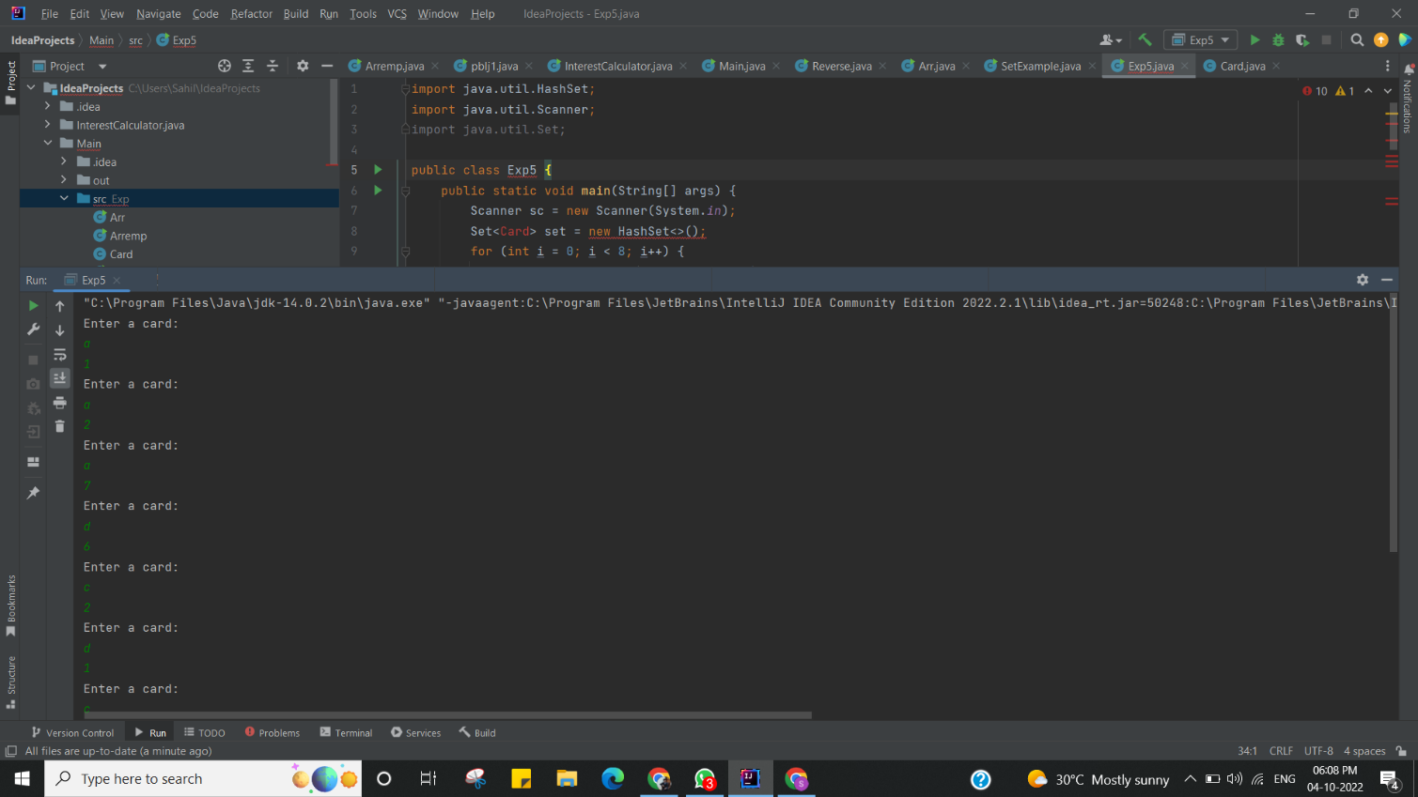

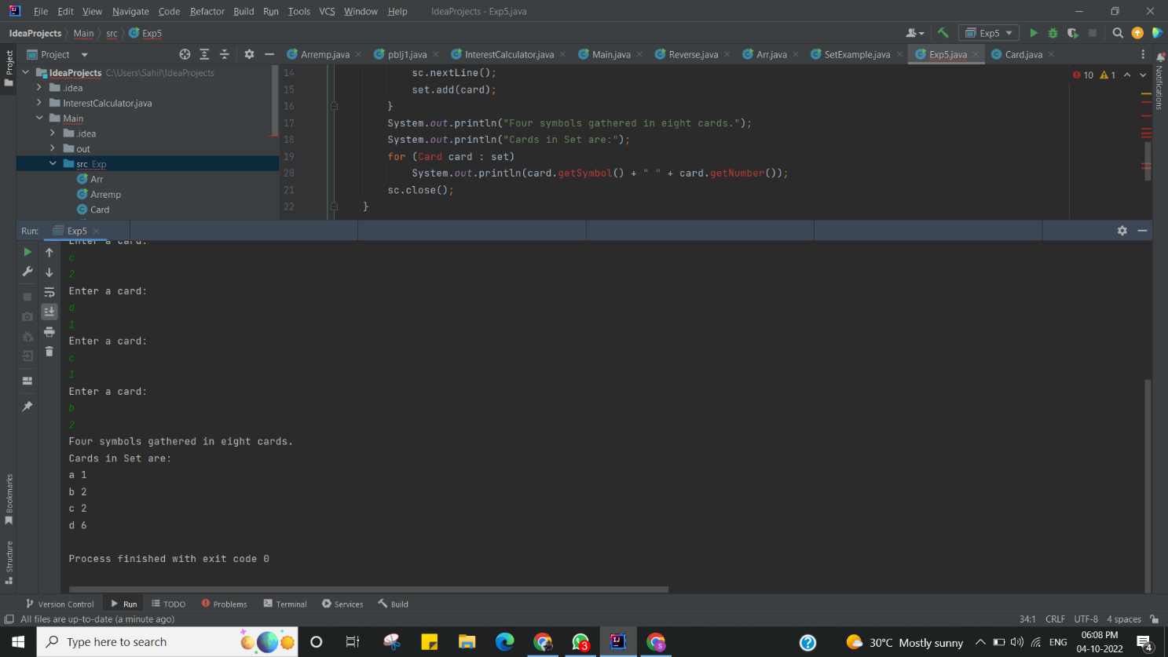

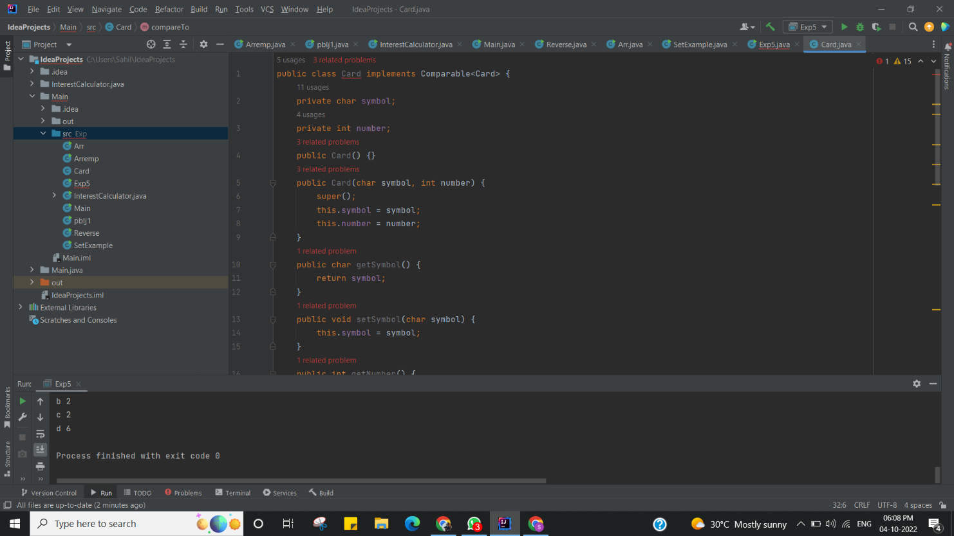

I have successfully done this program.

**Learning Outcomes (What I have learnt):**

* Learnt How to create the HashSet and insert the values to it.
* Set manipulation concept understood.
* Created list and Imported list in to a set.
* Learnt the concept of Iterator.
* Learnt concept of Set to Array Conversion

**Evaluation Grid (To be created as per the SOP and Assessment guidelines by the faculty):**

|  |  |  |  |
| --- | --- | --- | --- |
| Sr. No. | Parameters | Marks Obtained | Maximum Marks |
| 1. |  |  |  |
| 2. |  |  |  |
| 3. |  |  |  |